Requirements Analysis Document

Audit Information Management System

# Revision History

|  |  |  |  |
| --- | --- | --- | --- |
| **Date** | **Author** | **Revision** | **Comments** |
| Oct 11, 2016 | Hussam Ihmaidi | 1.0 | Draft |
| Feb 17, 2017 | Hussam Ihmaidi | 2.0 | Add mockup screens |
| Apr 21, 2017 | Hussam Ihmaidi | 2.1 | Add more details |

# Table of Contents

1. Table of Contents 2

2. Introduction 3

3. Business Goals and Expected Achievements 3

4. Application’s Main Features 4

5. System Settings and Lookups Management 21

6. Dashboards and Reports 23

7. Appendix I 24

8. Workflows 25

# Introduction

Auditing office is following a predefined lifecycle for each job they have starting with a visit and ending with closing the job. This process is managed and monitored manually through excel sheets, in this project we’ll try to develop an application to help the managers and the auditors to complete their tasks in an easy and efficient way.

# Business Goals and Expected Achievements

The main goal of this project is to automate the lifecycle of auditing process and to have a one system that auditors and managers can use to manage all auditing jobs, tasks and stages, in addition of the invoicing and collecting tasks.

By completing this project we will try to achieve the following points:

1. Automate the clients and leads information
2. Automate the auditing process steps
3. link the clients with invoices and collected payments
4. Simplify managing auditors performance
5. Have one application to manage audit jobs and contains all necessary data

# Application’s Main Features

AIMS Application will contain the following main features and services:

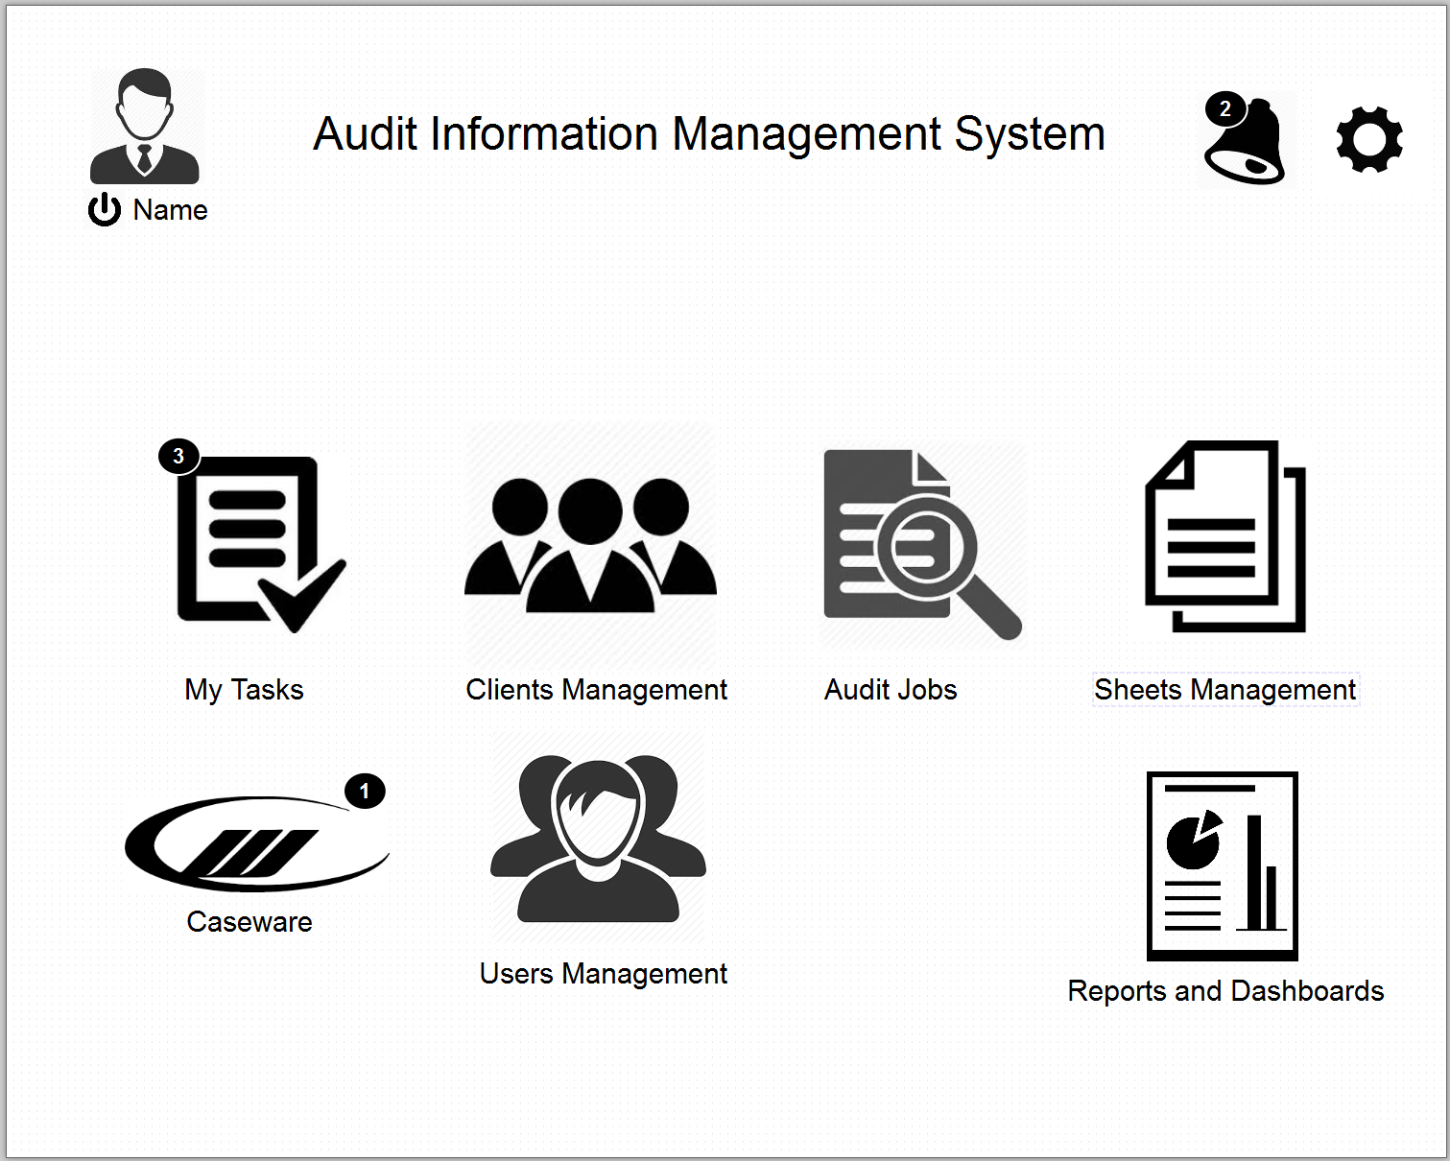

1. **Main Page**

The main page will contain shortcut icons to the main screens and functions of the system, the main icons of this page are:

* 1. **User Avatar/Photo** with logout icon
  2. **Alerts** icon, from which the user check his alerts, the icon has to show the number of new alerts and notification.
  3. **My Tasks** icon, this icon has to show the number of tasks in the user’s inbox and from this icon the user can go to “My Tasks” page.
  4. **Clients Management** icon, from this icon the authorized user can access the clients management page
  5. **Audit Jobs** icon, from this icon the authorized user can access the Audit Jobs.
  6. **Sheets Management** icon, from this icon the authorized user can access the budget/actual sheets data.
  7. **Users Management** icon from this icon the authorized user can access the user’s management pages.
  8. **Caseware** icon, this icon has to show the number of caseware files available for the user, and the user can use this icon to access all caseware files sent to him or to send files to other users.
  9. **Reports and Dashboard** icon, from this icon the user may access all the reports and dashboard that are granted to him
  10. **Settings** icon, the authorized user may use this icon to access the settings page.

1. **Clients Management**

In this part, the user can manage all the new and old client’s or lead’s data, the user may use this page to do the following: 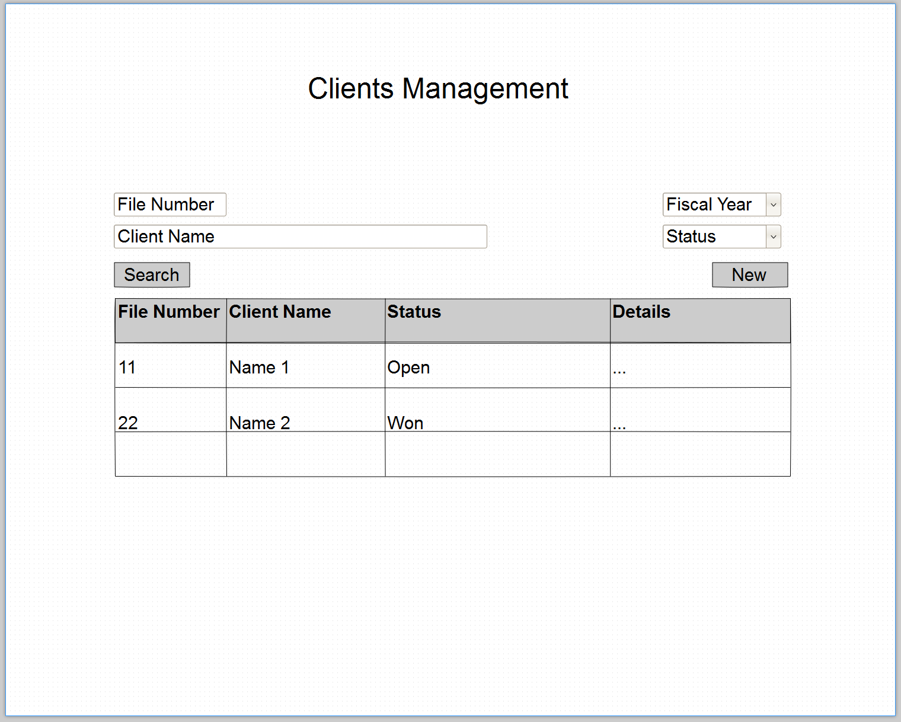

* 1. **Create new file for a lead or a client**

The user has to fill the following data for the new record

1. File Number (if left null the system has to give an auto file number)
2. Client Name
3. Status
   1. Open
   2. Semi-Open
   3. Closed-Lost
   4. Proposal
   5. Won
4. Ownership (Saudi or Foreign )
5. Telephone
6. Fax
7. website
8. email
9. city
10. address
11. Contacts, the user may add/edit/delete contact record
12. Authorized Employee

Once the user selects the status; the system has to manage the status as follows

* If the status is **open** the system has to send a task to the authorized user to follow-up if the status is not changed within 30 days, after other 30 days if the status not changed the system has to change the status to **semi-open** and send a notification to the authorized user with the new status.
* If the status is **semi-open** the system has to send a task to the authorized user to follow-up if the status is not changed within 30 days, after other 30 days if the status not changed the system has to change the status to **closed** and send a notification to the authorized user with the new status.
  1. **Search for a lead or client’s data**, user may search for a client or a leadby using the following search parameters

1. File Number
2. Client Name
3. Fiscal Year
   1. Jun-2015
   2. Jun-2016
   3. Jun-2017
   4. ….
4. Status
   1. Open
   2. Semi-Open
   3. Closed-Lost
   4. Proposal
   5. Won
   6. All

The user may access the client’s data by clicking on the details icon

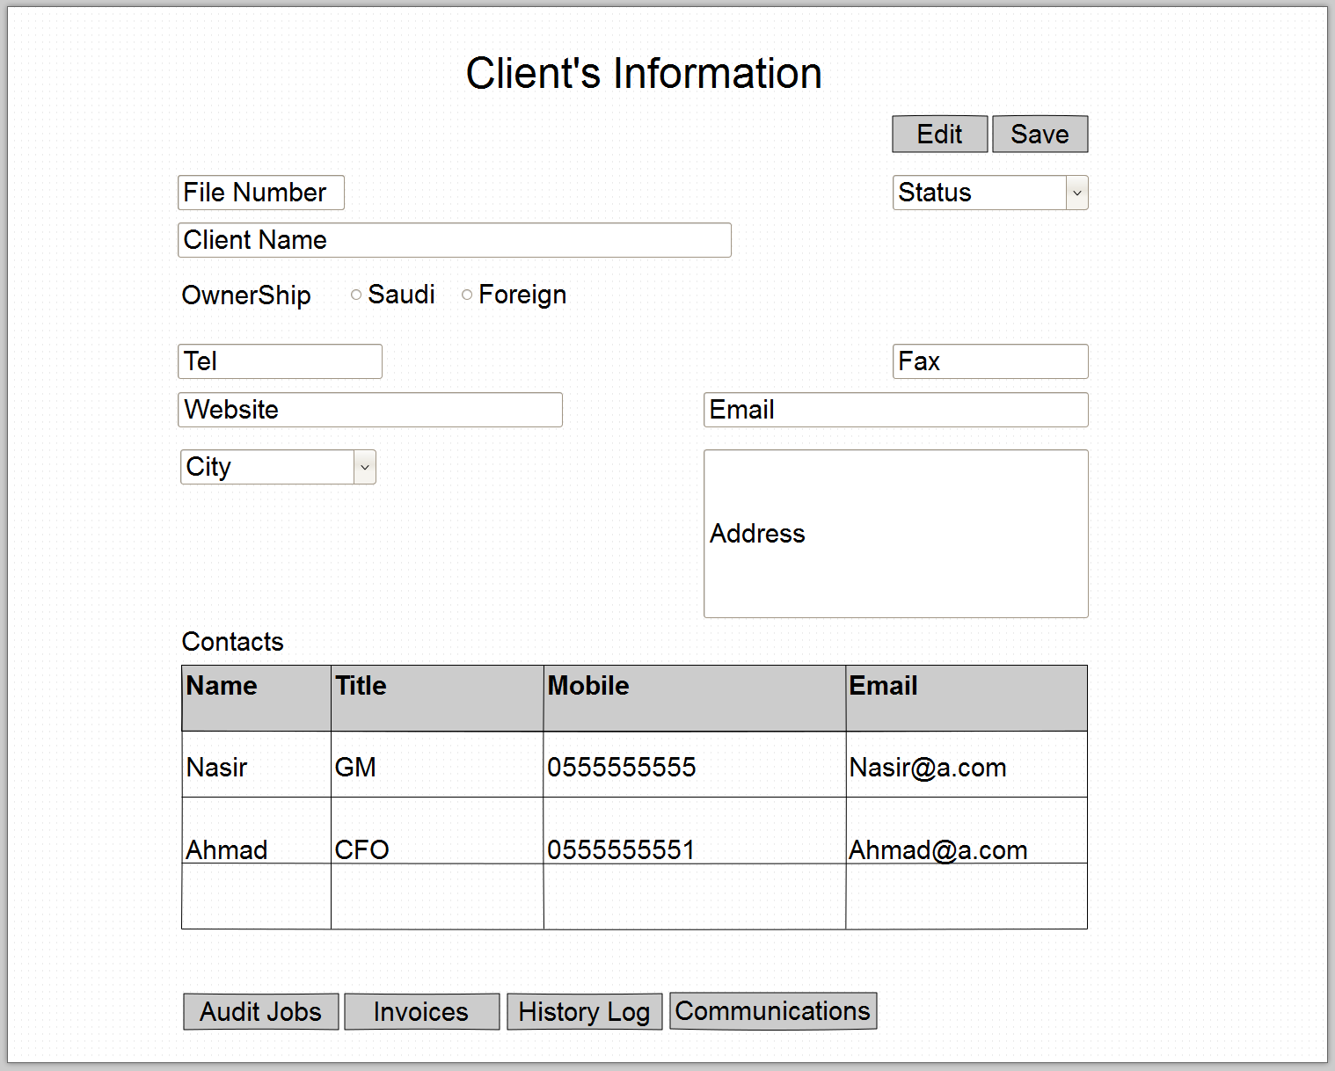

* 1. **View/edit client’s data**, the user may view the following data

From this page the user can change the status of the clients profile from Open to Semi-Open to Proposal to Won.

1. File Number
2. Client Name
3. Status
4. Open
5. Semi-Open
6. Closed-Lost
7. Proposal
8. Won
9. Ownership (Saudi or Foreign )
10. Telephone
11. Fax
12. website
13. email
14. city
15. address
16. **Contacts**, the user may add/edit/delete contact record
17. **Audit Jobs Button**, by clicking on this button the user will open the clients audit jobs data

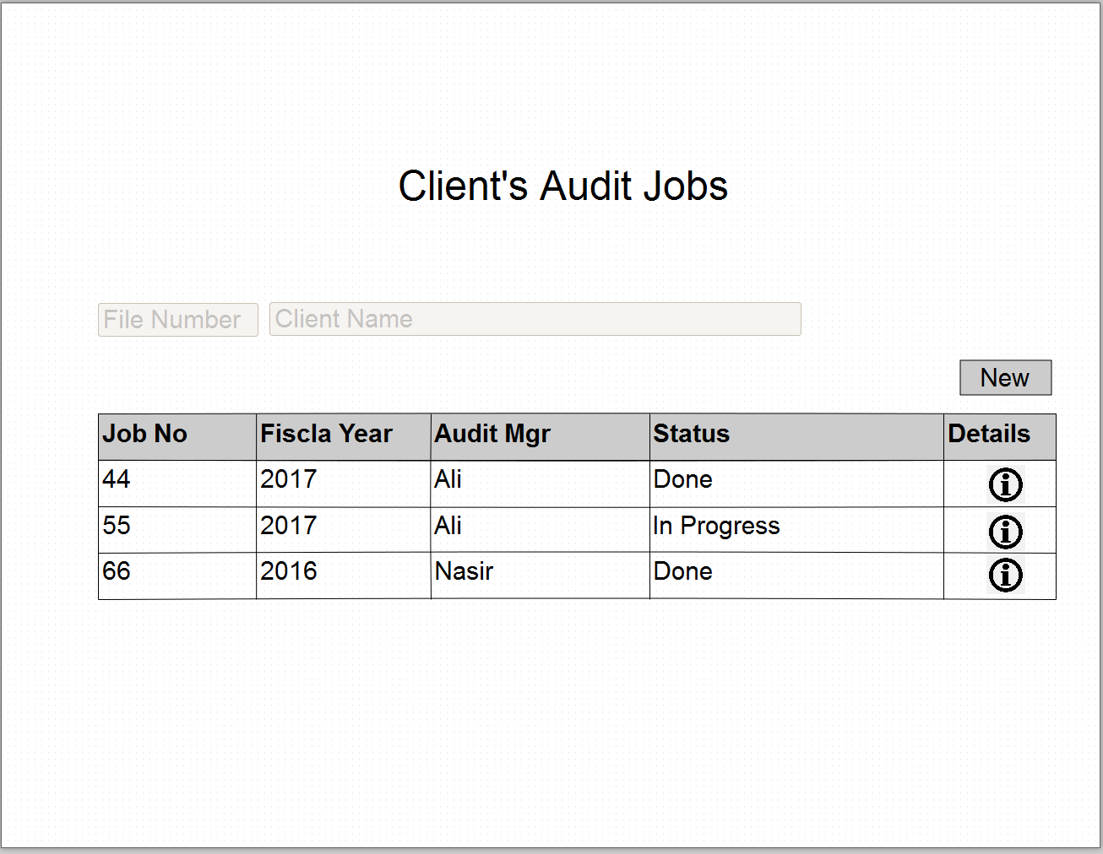

From this page, the user may edit/view existing audit job; on the other hand the user may create new audit job for the selected client.

1. **Invoices Button**, by clicking on this button the user will open the invoices page

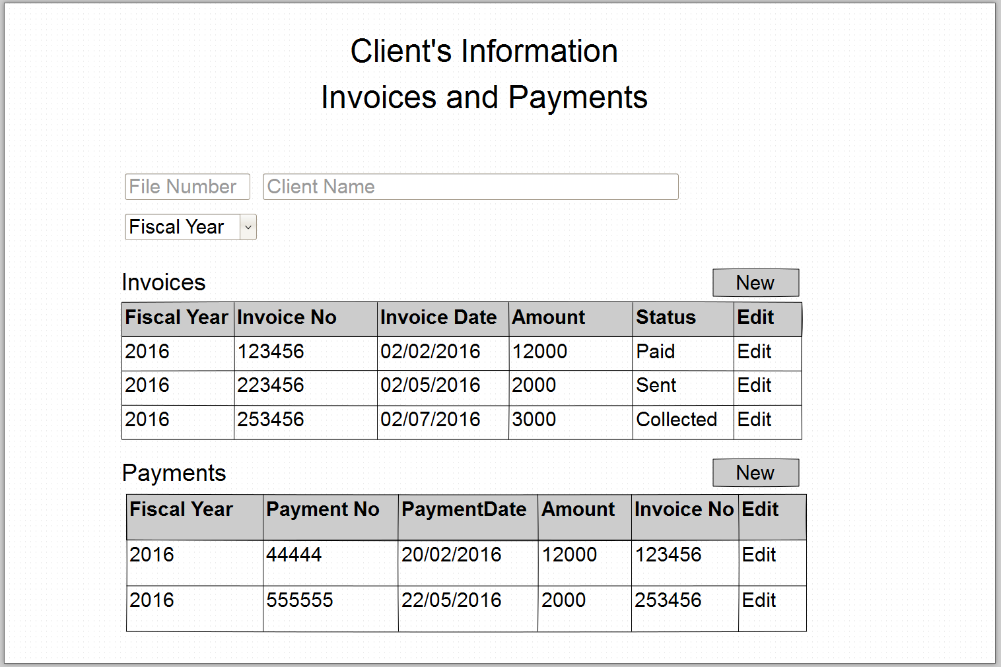

From this page the user has to select the fiscal year, although the user mays select all, then the system will show all invoices and payments according to the selected fiscal year, the user may click on edit to modify the record or may click on new to add new record.

1. **History Log Button,** by clicking on this button the user will open the history log for the client, the history log includes the activity list like visits, sending proposals, sending invoices, etc.…
2. **Communications Button**, by clicking on this button the user will open all communications with the client,

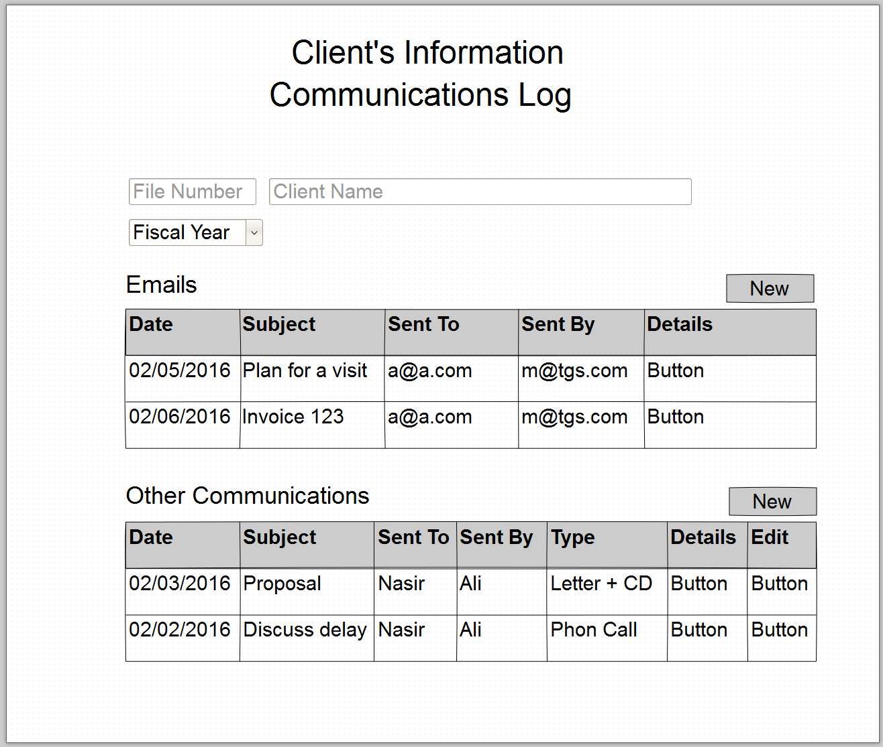

This screen is divided into two sections, one for emails and one for other type of communications. From emails section; the system has to load all emails sent to the client, on the other hand, the user may create an email by clicking on the “new” button, the system has to open for the user an email page, this page has to show all main send email features and has to load the “send from email account” from the user’s profile.

From the other communications section; the user may view/add any sent letters or phone call done with the client.

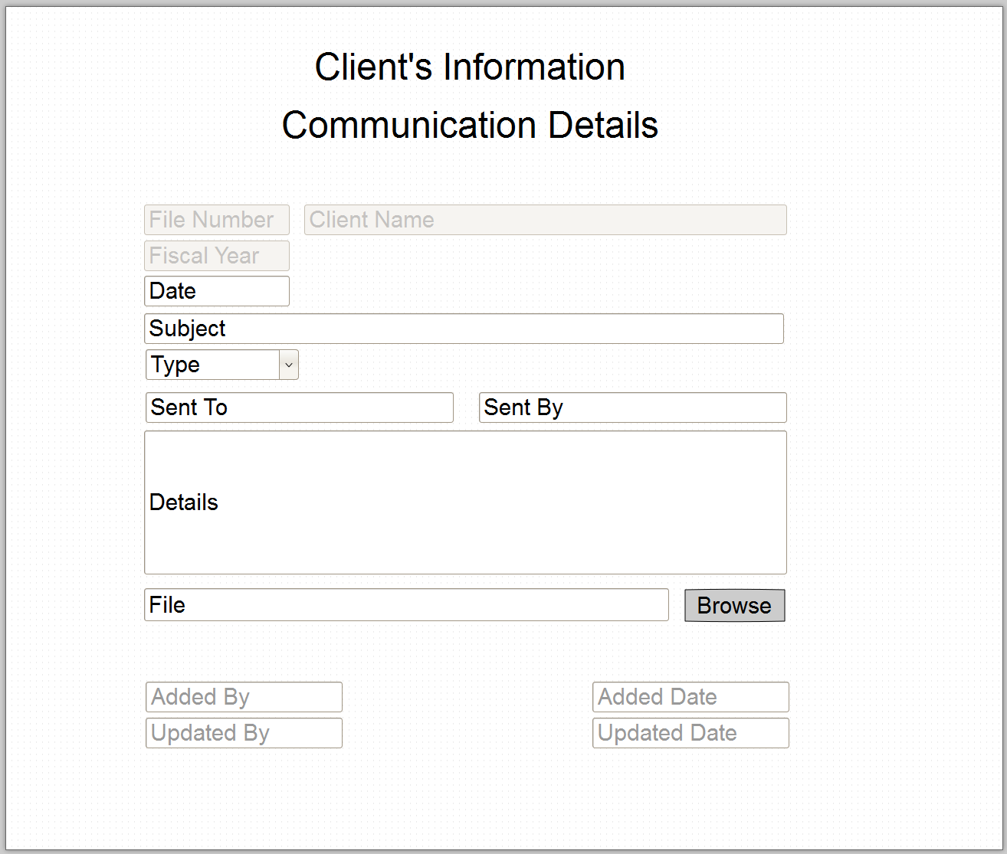

User may edit by clicking on edit button or add new communication by clicking on the New Button, a new page will be opened for him that contains the following fields:

* Date
* Subject
* Sent To
* Sent By
* Type (Letter, Phone Call)
* File
* Details
* In the insertion mode the system has to add insert by and insert date, and on the update mode the system has to inset the update by user and update by date.

1. **Audit Jobs Management**

From this page the user can search for audit job and he can view/edit the details of the audit job

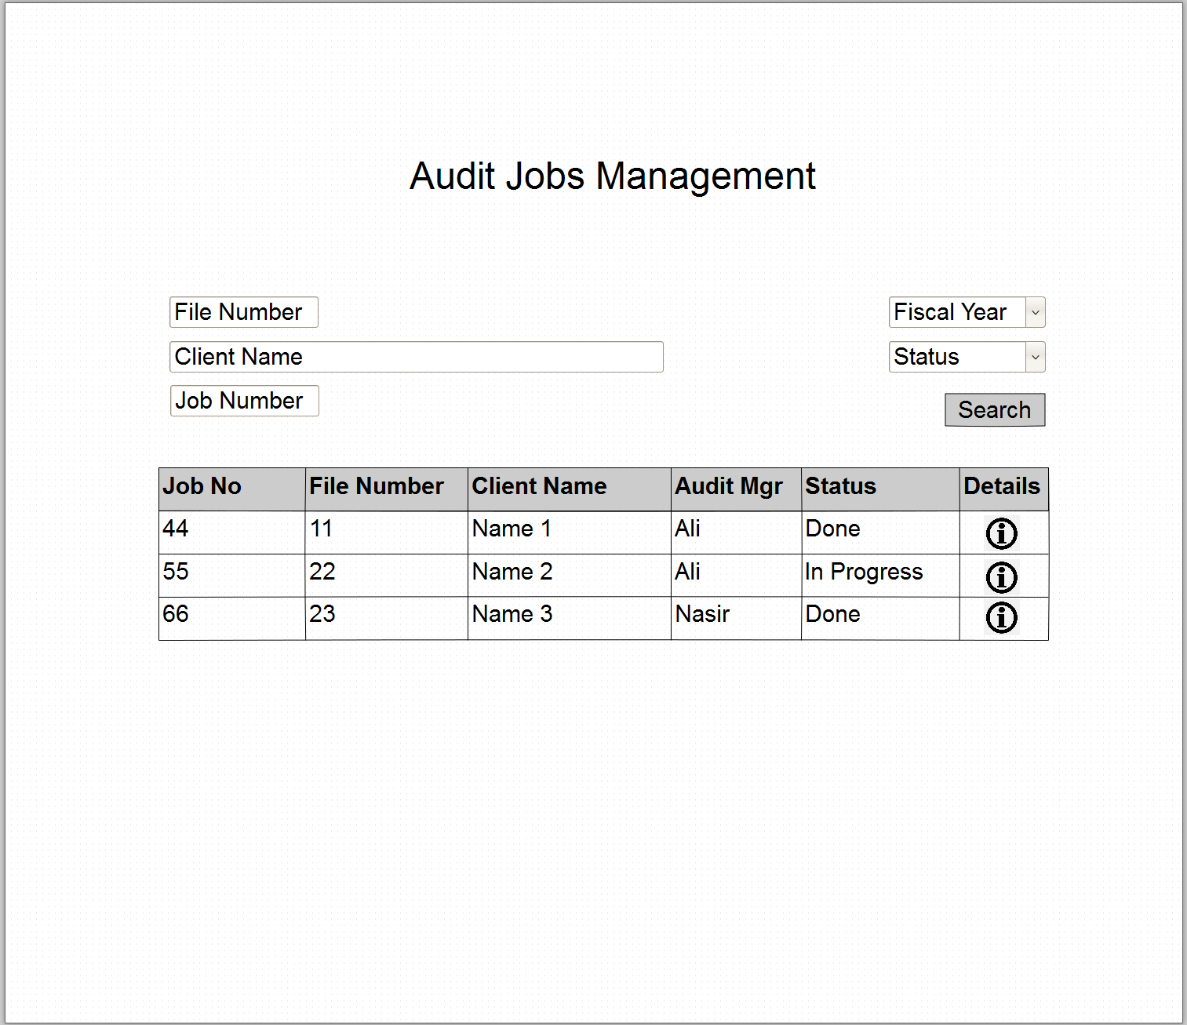

From this page, the user can add/edit Audit job details; the system has to load the file number and client’s name as display fields.

From this screen, the user can do the following functions:

* Fill the Audit job main data(Manager, Audit, Fiscal Year)
* Fill the audit job steps details by selecting the dates and the status for each step
* open “budget sheet” screen
* open “actual sheet” screen

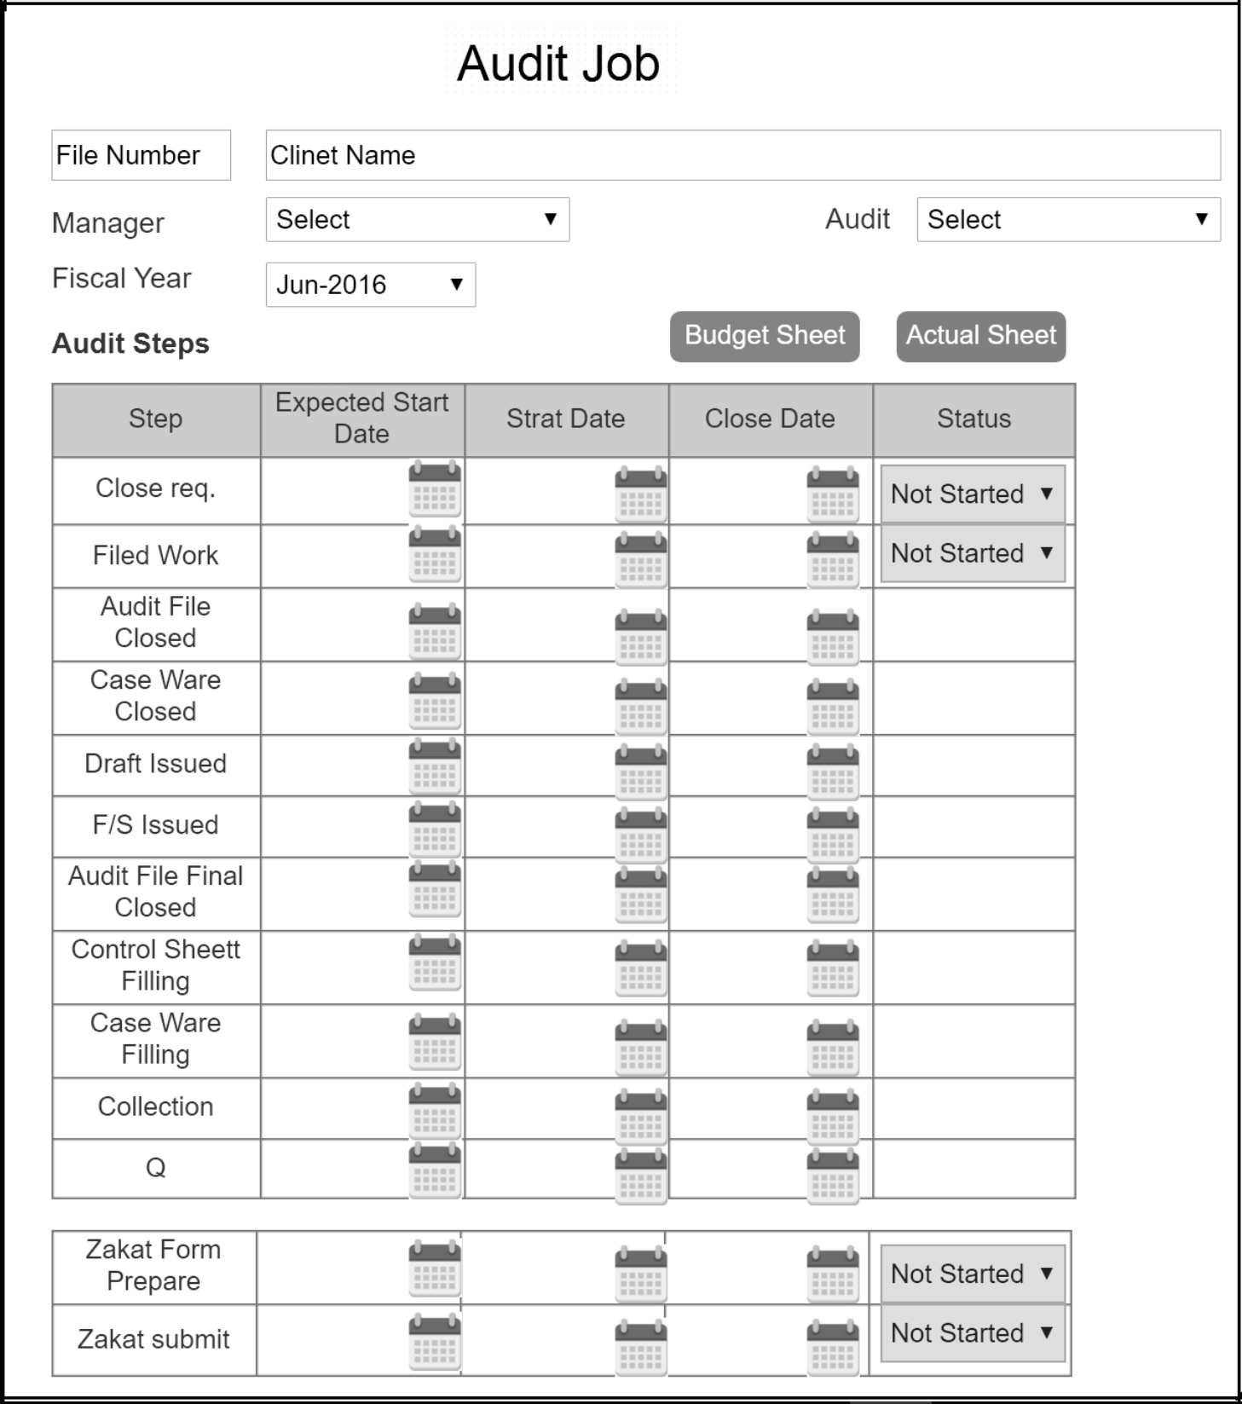

1. **Budget/Actual Sheets Management**

Budget sheets are used to estimate the tasks and the cost for an audit job,the user may create the budget sheet by selecting the tasks items and specify the employee type for each task.

After the creating the budget sheet the user may create the actual sheet for this budget sheet. The following screens shows how the user can manage budget and actual sheets.

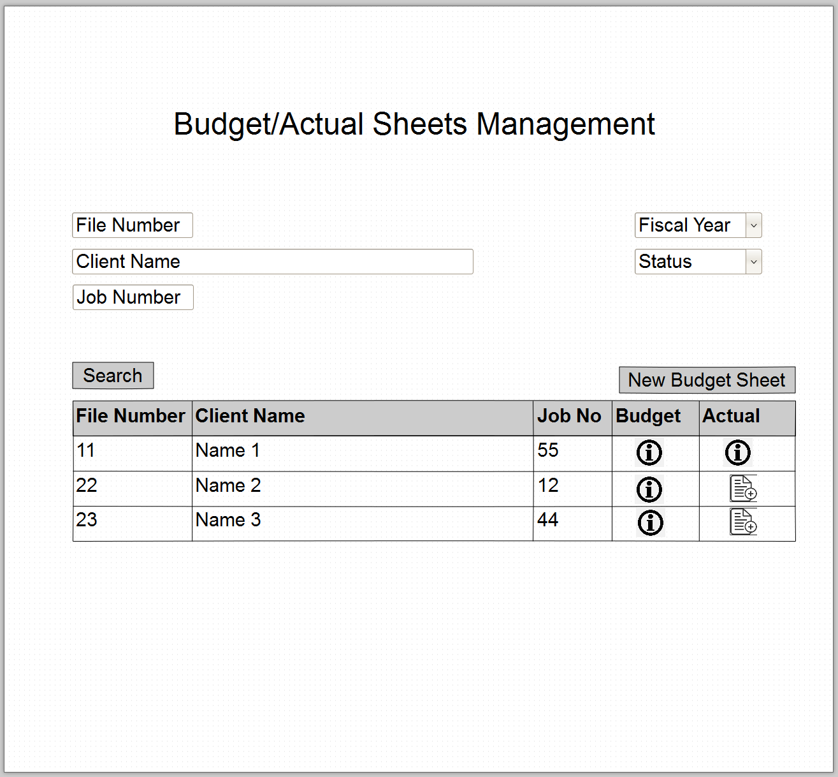

From this screen the user can do the following functions:

* search for all clients and their available sheets
* open create “new budget sheet” screen
* open create “actual sheet” from created budget sheet record
  1. **Budget Sheet Screen**

The user may access the budget sheet page from the main budget/actual sheets management page, or from the Audit job page.

Budget sheet has the following main parts

* + **Budget sheet main data**, that includes the following fields
    - clients file number
    - fiscal year
    - Created Date
    - Status (Under Development, Draft, Final)
    - Job number
    - Job type (Final, Intrim, Quarter) audit
    - Job location; outside main city or inside main city, if the user selects outside the system has to show the “Cost of Outside Main City” part
  + **Main sheet tasks,** that will be used to specify all tasks that will be done for the job, user can manage the tasks list as follows
    - User can add a record by clicking on the “Add” button, so the system will give him the ability to inter data for the fields on the record, once a new record opened the user may pick from the tasks list in the “Description” field, system has to show only unselected items only.
    - User may edit any record by clicking on the edit icon.
    - User may delete after a confirmation message any selected record by clicking on the delete icon.
    - User may select the employee who will be responsible about the task by clicking on the employee icon.
    - The system has to do load the hourly rates form the preconfigured data
    - The system has to do all needed calculations that will be show in the calculation fields
  + **Cost for Outside Main City**, this part will be accessible only for jobs outside main city user has to fill the number of days for each employee type, the system has to load the day rates, car rent average rate, and transportation form/to the airport rate from the preconfigured data and do all needed calculations
  + **Final total amounts part**, this part shows the total amounts and the profit margin will be used
  + **Print budget sheet icon**, from this icon the user may print a printable version for the budget sheet

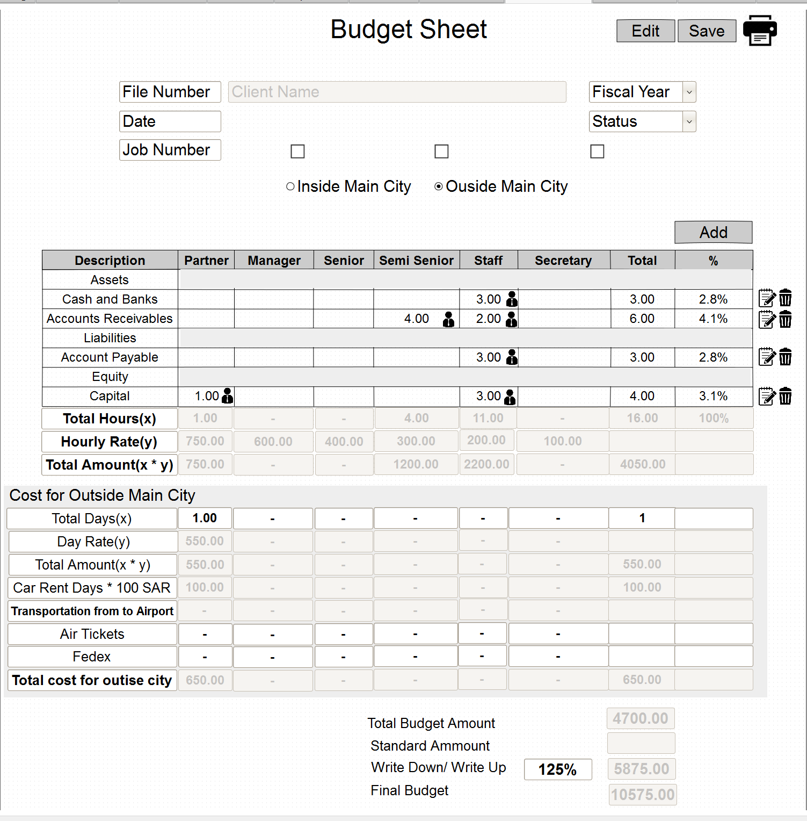

* 1. **Actual Sheet Screen**

The user may create an actual sheet for a pre-created budge sheet, when the actual sheet is created, it must load all data of the budget sheet with edit mode, the user has to fill the actual data and save the document.

The main data of the actuals sheet must be disabled except the status drop down list.

The user may access the actual sheet page from the main budget/actual sheets management page, or from the Audit job page.

The user may edit, add, delete any item; on the other hand, the user may re-select the employee for each task.

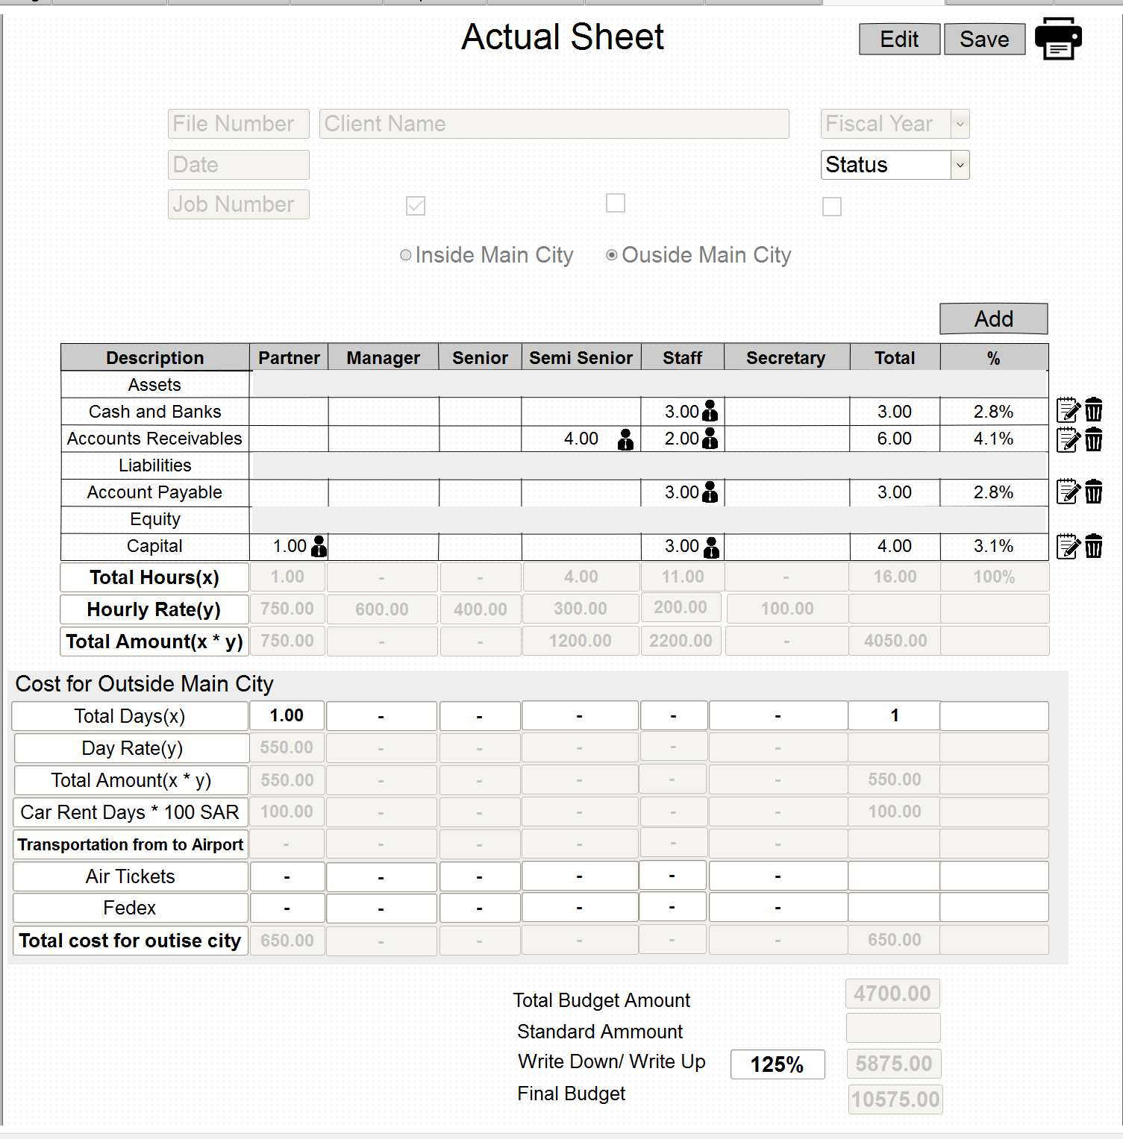

1. **Users Management**
   1. Manage the users accounts

In this part, the portal’s admin can manage all user accounts and all security roles.

|  |  |
| --- | --- |
| ## | Use Case |
| UC 5.1.1 | Add/ Edit/ Activate / Deactivate user account |
| UC 5.1.2 | Reset user’s password |
| UC 5.1.3 | Manage user’s roles |
| UC 5.1.4 | Add/ Edit/ Activate / Deactivate system’s roles |
| UC 5.1.5 | Add/ Edit/ Delete/ Activate / Deactivate users groups |

1. **Notifications and Alerts**

In this page the system has to show to the user all notifications and alerts that are related to him, the notifications and alerts can be initiated from different places from the system like

* Clients Management, once the status of any client file changed; the related user must be notified with the change
* Clients follow-up, once a follow-up with a client has to be done the related user must be notified
* Audit job status, once the status of any audit job changed; the related user must be notified with the change.

The user can check the details of the notifications, and he can clear the notification from his list

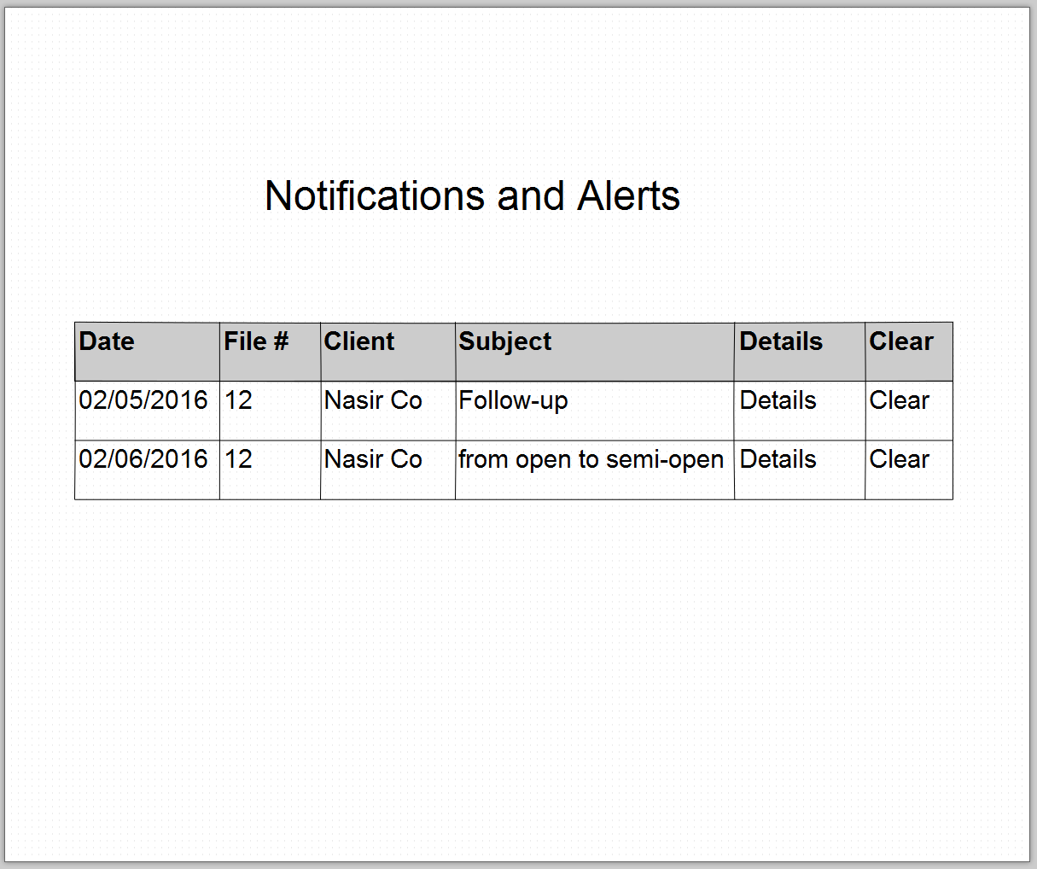

1. **Caseware Files Management**

In this page the user can send or receive caseware files, the user can send a caseware file to a specific user by the following steps:

* Select File Number/Client
* Browse for a file
* Select a user from users list

On the other hand, the user may receive caseware files from other users so he can download the file and he can remove the downloaded file record form the files table

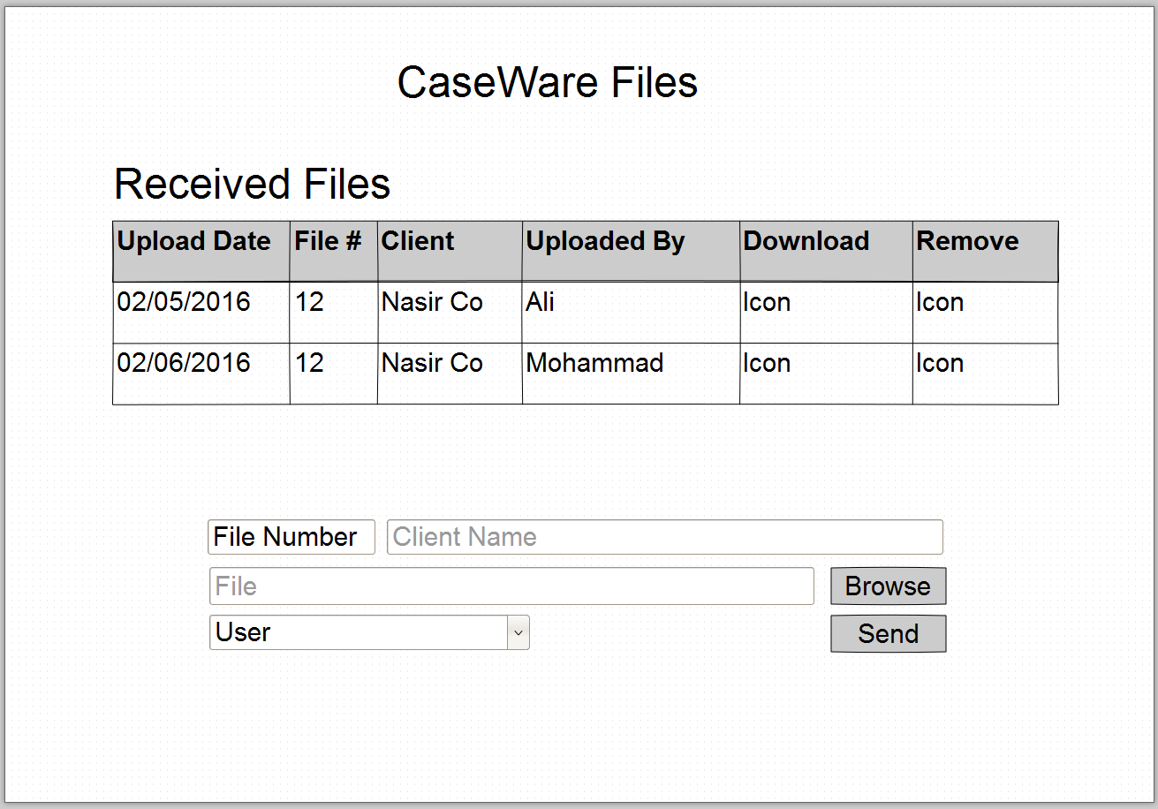

# System Settings and Lookups Management

**8.1 Employee’s Hours Cost Management**

In this page the user can manage the rate of employee’s hour to be used in budget and actual sheets

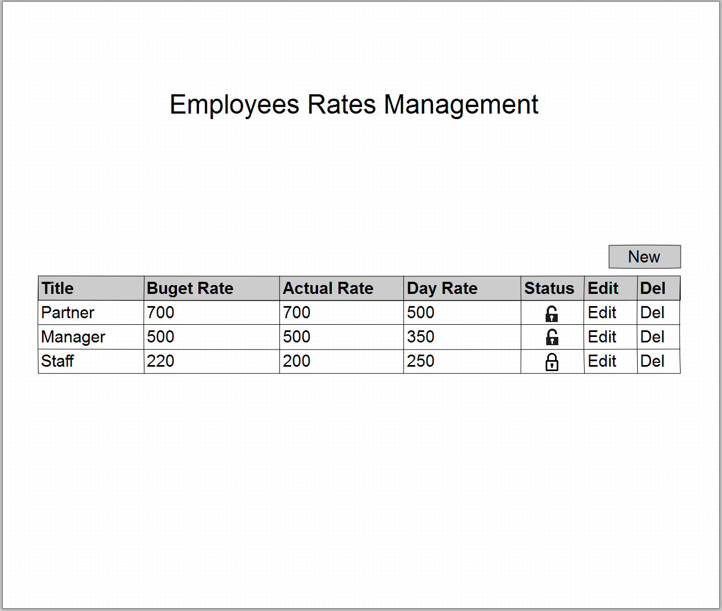

**8.2 Budget/Actual Sheet Items Management**

In this page the user can manage the task items that will to be used in budget and actual sheets

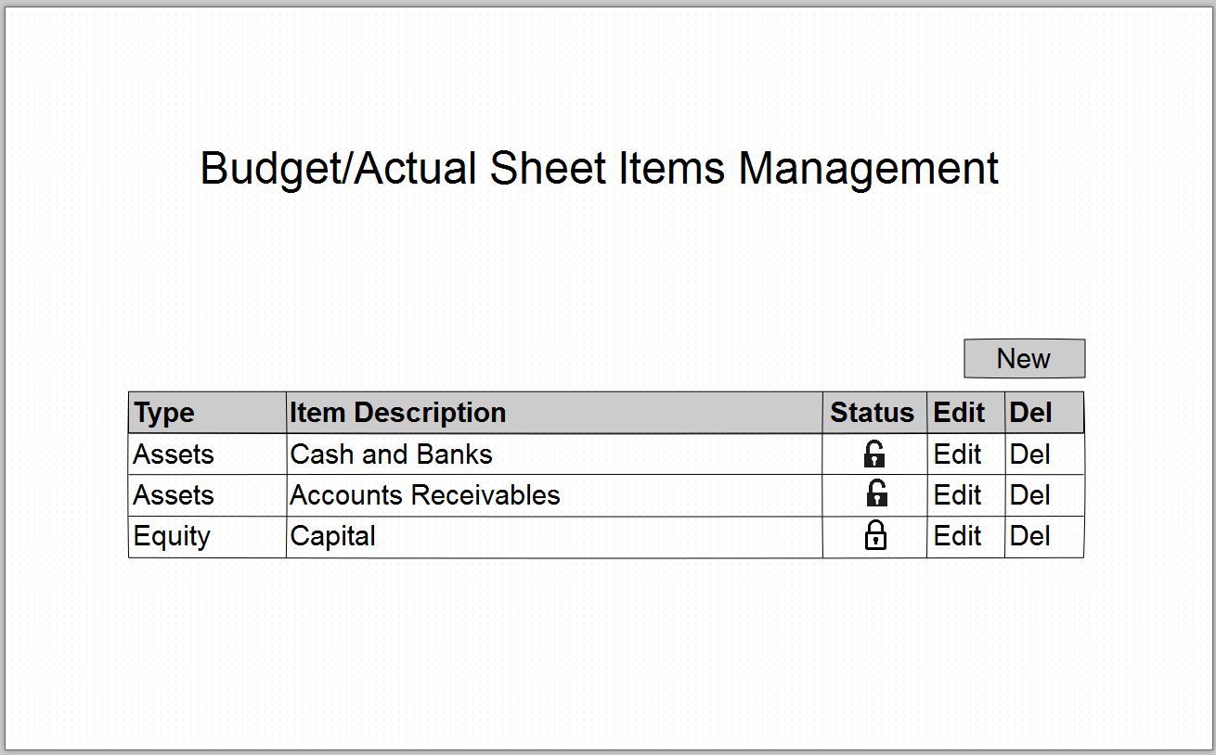

**8.3 Fiscal Year Management**

In this page, the user can manage close old fiscal year, and open new fiscal year.

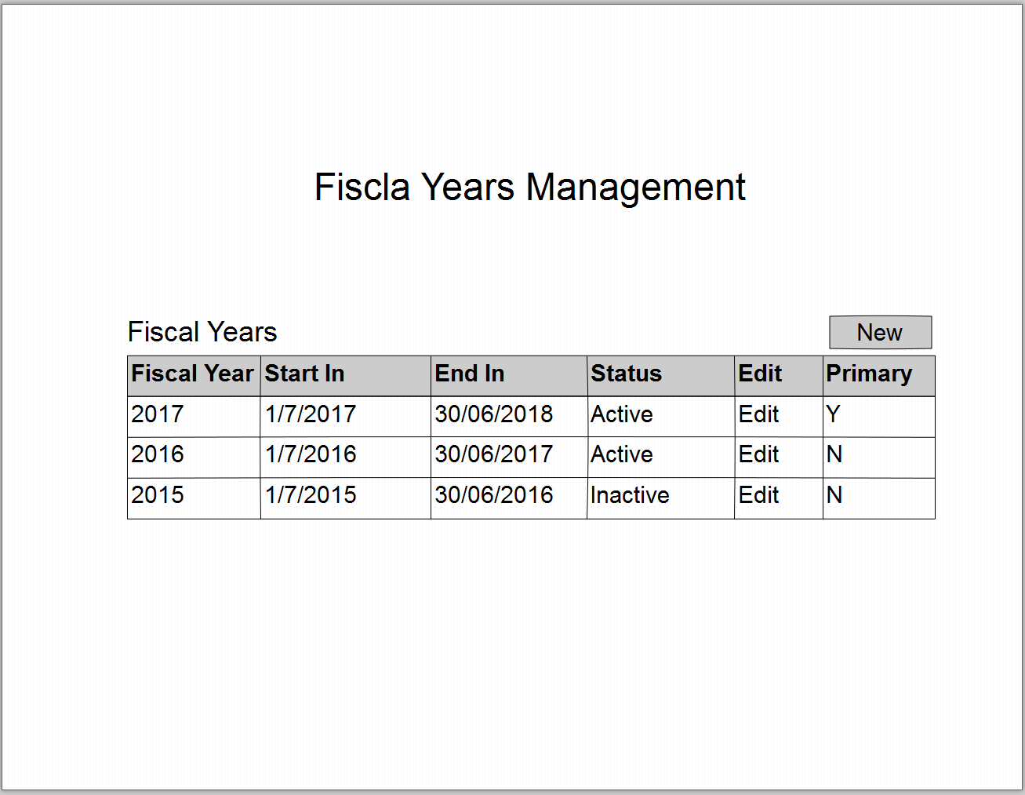Only one fiscal year can be selected as primary, all active fiscal years has to be shown under the fiscal year drop down list in other pages.

# Dashboards and Reports

# Appendix I

The following table contains all Tasks Items to be used in budget/actual sheets

|  |  |
| --- | --- |
| Type |  |
| Assets | Cash and Banks |
|  | Accounts Receivables |
|  | …. |
| Liabilities | Account Payable |
|  | Short Term Loans |
|  | …. |
| Equity | Capital |
| Profit and Loss | Revenue |
|  | …. |

# Workflows

This workflow shows how the lead follow-up starts and how it end by either winning the job or by closing it.

WF-001